**DYNAMIC ROUTING USING LINK-STATE OSPF PROTOCOL**

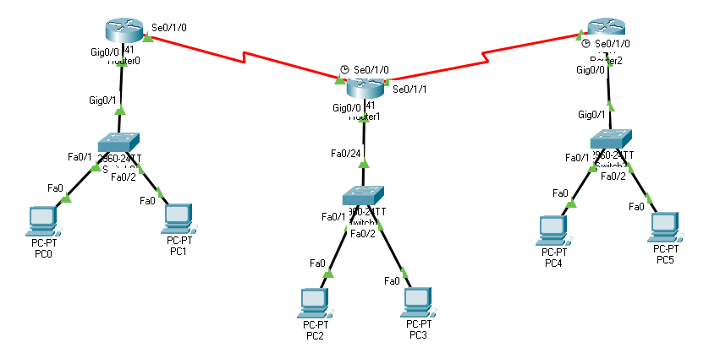

**Router 1 Basic Configuration**

Router>

Router>enable

Router#conf terminal

Enter configuration commands, one per line. End with CNTL/Z.

Router(config)#

Router(config)#interface s0/1/0

Router(config-if)#ip address 192.168.1.1 255.255.255.0

Router(config-if)#no shutdown

Router(config-if)#exit

Router(config)#

Router(config)#interface g0/0

Router(config-if)#ip address 10.0.0.1 255.0.0.0

Router(config-if)#no shutdown

Router(config-if)#exit

Router(config)#

**Router 1 OSPF Protocol Configuration**

Router>

Router#conf terminal

Router(config)#router ospf 10

Router(config-router)#network 10.0.0.0 0.255.255.255 area 1

Router(config-router)#network 192.168.1.0 0.0.0.255 area 1

Router(config-router)#^Z

Router#write

Building configuration...

[OK]

Router#



**Router 2 Basic Configuration**

Router>enable

Router#conf terminal

Router(config)#

Router(config)#interface s0/1/1

Router(config-if)#ip address 192.168.2.1 255.255.255.0

Router(config-if)#no shutdown

Router(config-if)#exit

Router(config)#

Router(config)#interface g0/0

Router(config-if)#ip address 20.0.0.1 255.0.0.0

Router(config-if)#no shutdown

Router(config-if)#exit

Router(config)#

Router(config)#interface s0/1/0

Router(config-if)#ip address 192.168.1.2 255.255.255.0^

Router(config-if)#no shutdown

Router(config-if)#^Z

Router#write

Building configuration... [OK]

Router#

**Router 1 OSPF Protocol Configuration**

Router>

Router#

Router#conf terminal

Router(config)#router ospf 10

Router(config-router)#network 20.0.0.0 0.255.255.255 area 1

Router(config-router)#network 192.168.1.0 0.0.0.255 area 1

Router(config-router)#network 192.168.2.0 0.0.0.255 area 1

Router(config-router)#^Z

Router#write Building configuration.. [OK]



**Router 2 Basic Configuration**

Router>enable

Router#conf terminal

Router(config)#

Router(config)#interface s0/1/0

Router(config-if)#ip address 192.168.2.2 255.255.255.0

Router(config-if)#no shutdown

Router(config-if)#exit

Router(config)#

Router(config)#interface g0/0

Router(config-if)# ip address 30.0.0.1 255.0.0.0

Router(config-if)#no shutdown

Router(config-if)#^Z

Router#write

Building configuration...

[OK]

**Router 1 OSPF Protocol Configuration**

Router#conf terminal

Router(config)#

Router(config)#router ospf 10

Router(config-router)#network 30.0.0.0 0.255.255.255 area 1

Router(config-router)#network 192.168.2.0 0.0.0.255 area 1

Router(config-router)#^Z

Router#

Router#write

Building configuration...

[OK]